**Series and parallel Diodes**

**Lab No#03**



**Spring 2021**

**CSE-206L Electronic Circuits Lab**

Submitted by: **Ashfaq Ahmad**

Registration No: **19PWCSE1795**

Class Section: **B**

“On my honor, as student of University of Engineering and Technology, I have neither given nor received unauthorized assistance on this academic work.”

Student Signature: ______________

Submitted to:

**Eng: Abdullah Hameed**

May 15, 2021

**Department of Computer Systems Engineering**

**University of Engineering and Technology, Peshawar**

**Objectives:**

* To study the characteristics of silicon diodes in series and in parallel.

**Equipment:**

* DC power supply

**Components:**

* Silicon (D1N4002)
* Potentiometer
* Resistor: 1kΩ,

**Theory:**

**Diode:**

A diode is a two-terminal electronic component that conducts current primarily in one direction; it has low resistance in one direction, and high resistance in the other.

**Series Configuration:**

Series connection means a side by side connection. When two components are connected in series, they have one common junction.

The variation of voltage and current in a series connection is as follows:

* Potential difference across every component is different.
* The current across every component connected in series remains the same.

When diodes are connected in parallel, this same trend is observed.

**Diode Characteristics in Series Configuration:**

When connected in series, we observe the following properties to hold true among the diodes:

* Resultant diode’s forward voltage increases.
* Reverse blocking capabilities of diodes are increased in series connection

**Schematic Diagram:**

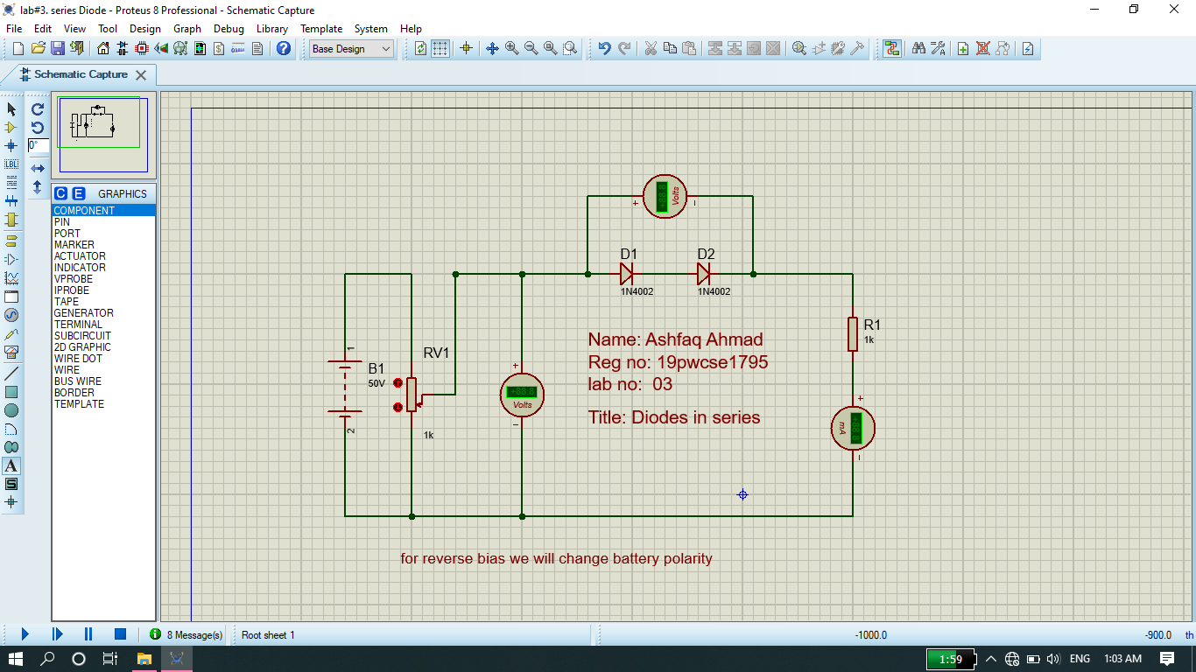

**Graph between current vs voltage (Forward bias in series):**

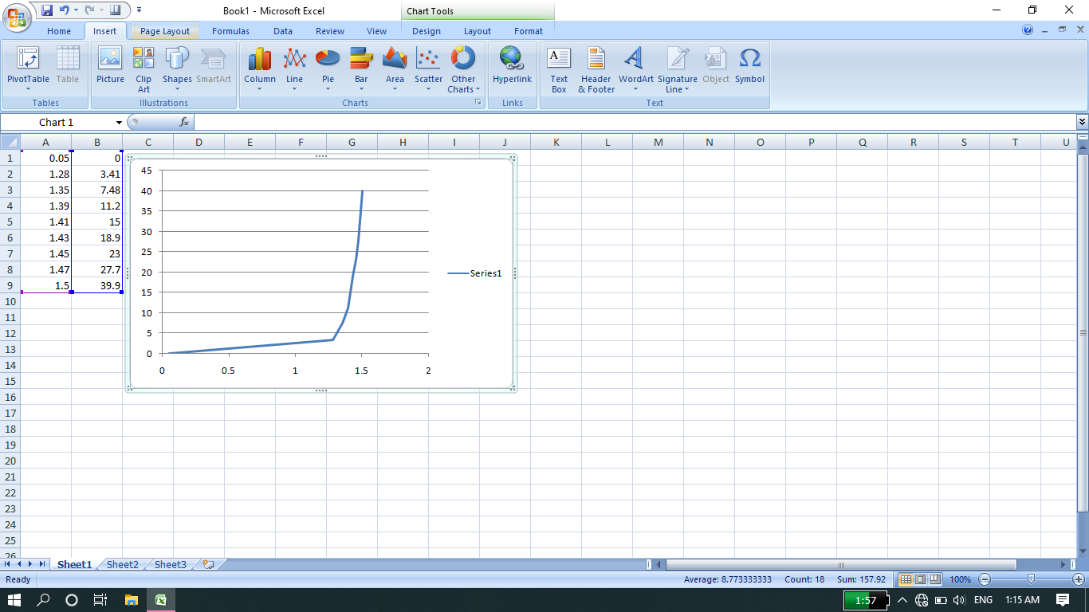

**Graph between current vs voltage (reverse bias in series):**

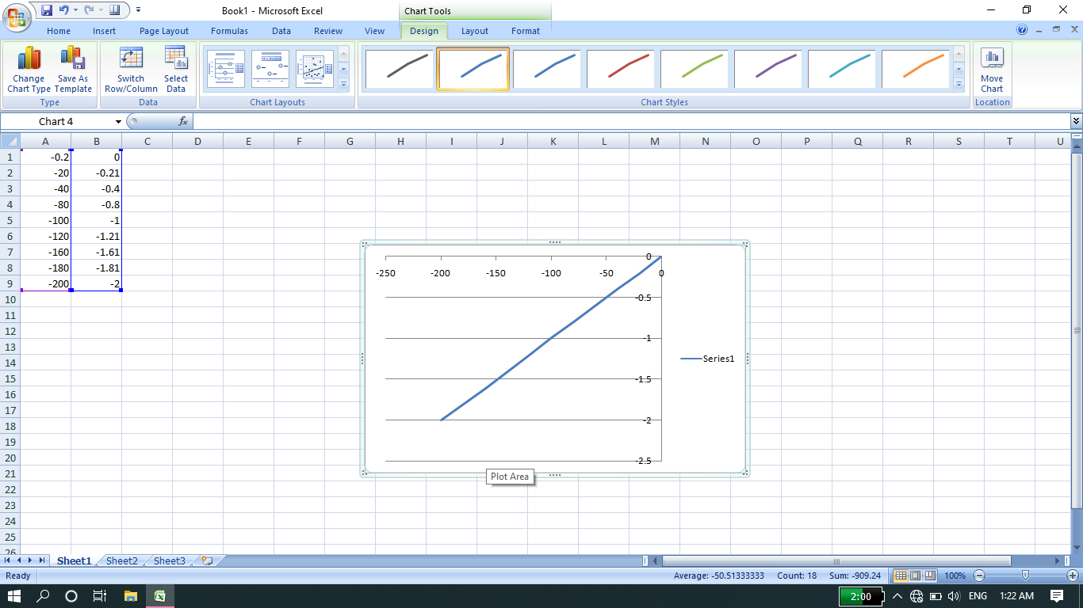

**Parallel configuration:**

Parallel connection means the components are connected across each other, having two common points.

The variation of voltage and current in a parallel connection is as follows:

* Potential difference across every component is same.
* The current across every component connected in parallel is different.

When diodes are connected in parallel, this same trend is observed.

**Diode Characteristics in Parallel Configuration**

* Current carrying capacity increases.
* No conduction in resultant diode in both sides.

**Schematic Diagram:**

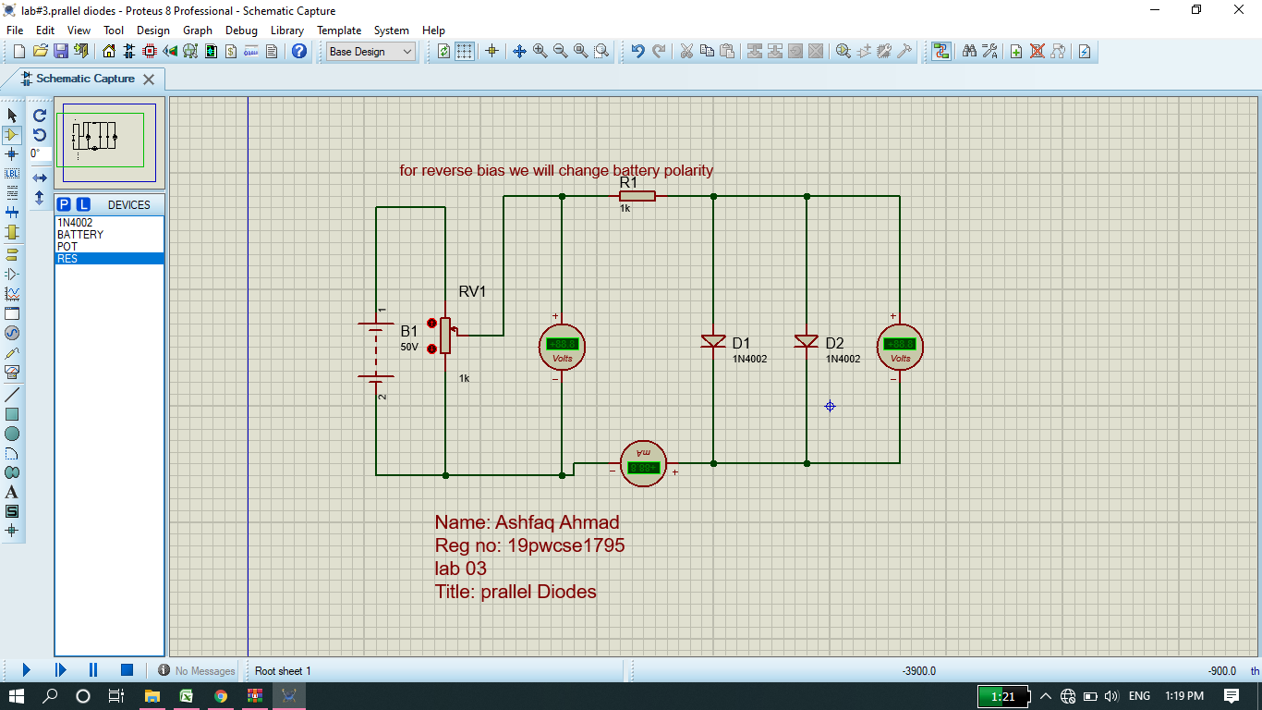

**Graph between current vs voltage (forward bias in parallel):**

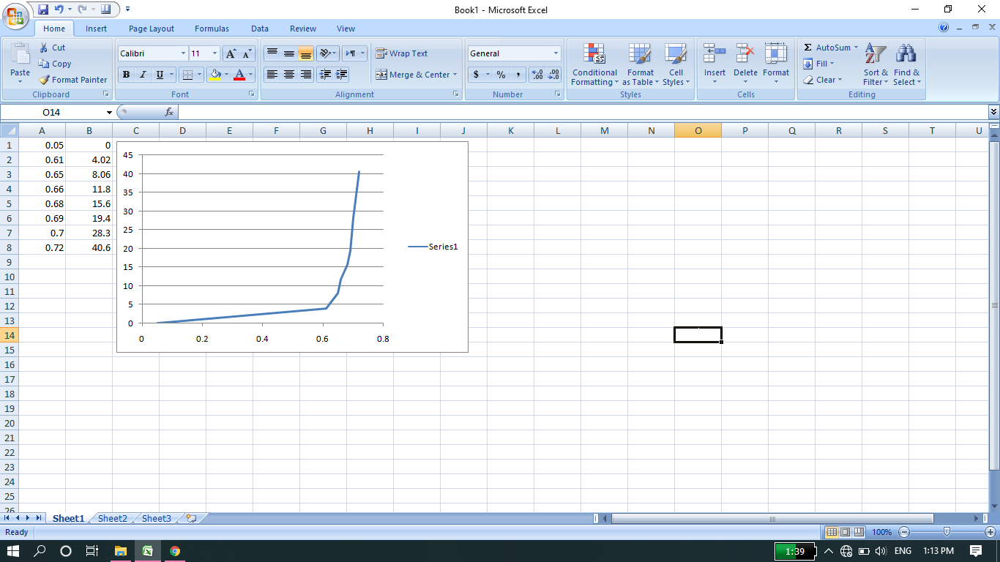

**Graph between current vs voltage (reverse bias in parallel):**



**Graph of single Diode for comparison:**

**Forward Bias:**

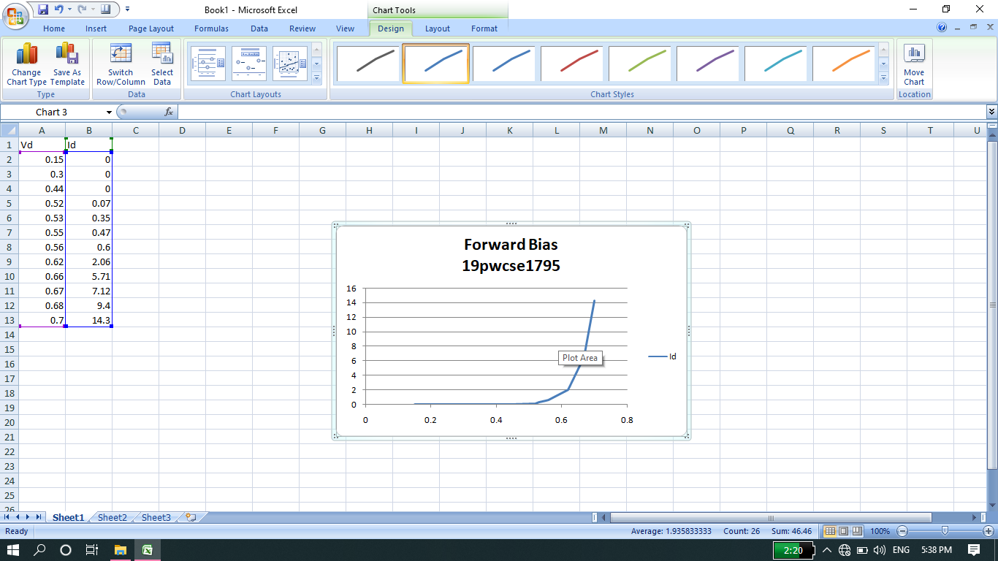

**Reverse Bias:**

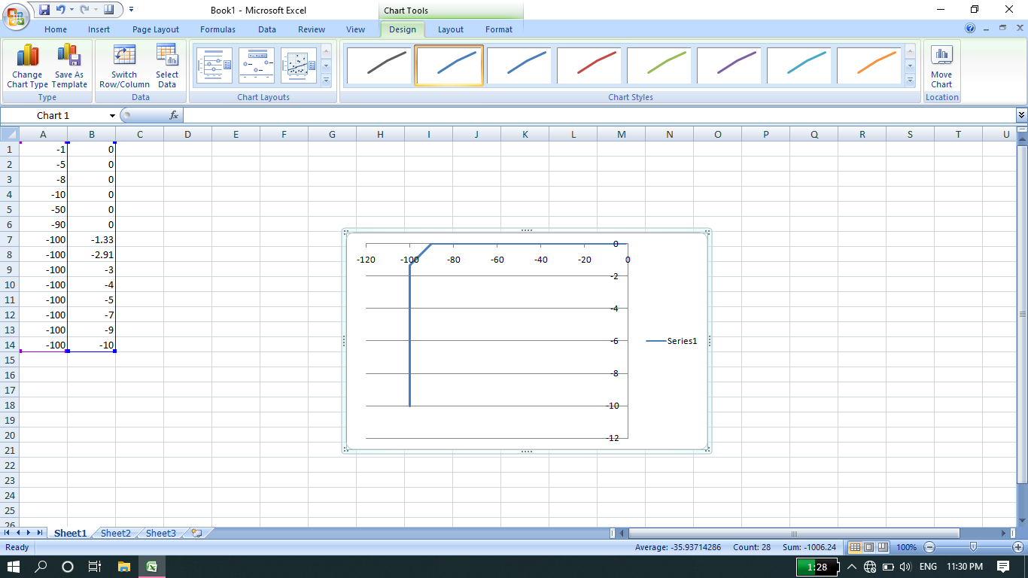

**Summary:**

* **After comparison we summarized that In case of forward bias (Series) the magnitude of voltage increase while in case of reverse bias (series) the blocking capabilities of Diode increase I,e not allow the current to increase exponentially which occur in case of single diode (reverse bias).**
* **In case of forward bias (parallel) we see that the current capacity increase by large amount as compare to current increase in case of single diode (forward bias), while in case of reverse bias (parallel) the same phenomena occur as in case of series I,e blocking capabilities of Diode increase I,e not allow the current to increase exponentially.**

**THEN END**